Virtual Motorman’s Guide
LT “Sarah Siddons” Locomotive for MSTS – June 2008
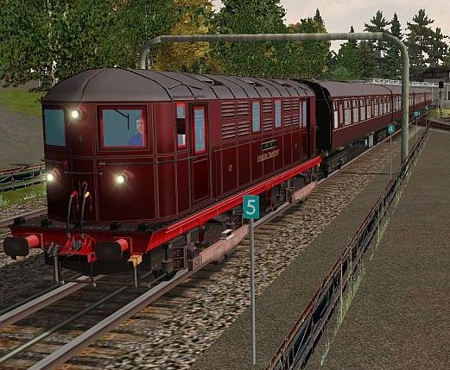
In his 1937 2-volume treatise “Electric Trains”, W.A. Agnew notes that in 1922 the London Transport Passenger Board ordered twenty 1200hp electric locomotives to be built by Metropolitan-Vickers Ltd. for service on the Metropolitan lines. The locos weighed about 56 tons and were designed to haul trains of about 180 tons at speeds up to 65mph. Each bogie was fitted with two axle-hung 300hp motors, providing a tractive effort of 31,400lb. The locos were designed with high acceleration for areas with frequent stops, and for high speed in areas with infrequent stops on the Met Main. They were originally fitted with both air (Westinghouse) and vacuum (Consolidated Brake Co Ltd.) brakes to handle differing types of coaching stock.
Today only two examples exist. Met #5 “John Hamden” is on static display at the LT Museum in Covent Garden. Met #12 “Sarah Siddons” is the last preserved working-order locomotive, and is stabled at the LT Museum at Acton Town making periodic ‘fan excursions’ on the Combine. The screenshot above shows MSTS Met #12 leaving Ealing Common EB, hauling 4 Mk1 coaches.
This model of Metropolitan Locomotive #12 “Sarah Siddons” was produced by a team of enthusiasts that included invaluable support and key contributions from several LUL professionals. Our goal was to create a realistic model of the real Met #12 Loco – in appearance, operation and performance. This guide is intended to help you become familiar with the loco, its controls and operation; and with practice to become a competent MSTS 1200hp Electric Locomotive Operator. Good luck, and enjoy!

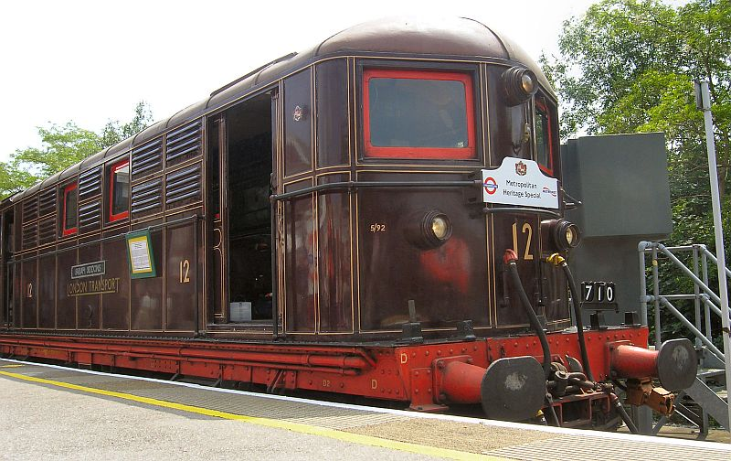
Welcome to your loco
Let’s first examine LT Met #12 Loco from the outside and look at some key features.
The loco normally uses drophead Buckeye couplers with drawhooks, and has buffers for emergency use. The brake air hoses can also be seen. A whistle is controlled in the cab by a button below the nearside front window, and is used at specific route locations (marked by Whistle Boards), or to warn Permanent Way crews working on or near the track of the train’s approach. The whistle and its brass control button are included in the MSTS model (controlled in MSTS by the <spacebar>). The window wiper is animated on the MSTS loco and is controlled by the “V” key.
The lights used depend on whether the unit is currently a ‘front’ or ‘rear’ unit (white headlights or red taillights illuminated as required). In the picture above, three white ‘front’ lights are shown illuminated. If the loco were at the rear of a consist, two red lights would be illuminated. The operation of the lighting with the MSTS train is discussed in a later section titled Train Lights.
Access to each end cab is through either side doors – double sliding doors on the offside (as seen above), and a single sliding door on the nearside.
The photo below shows a view through the offside doors, looking towards the nearside of the cab.
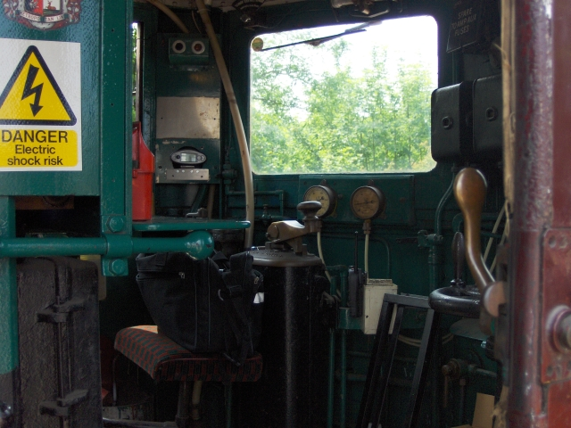
We can tell this is the current ‘front’ cab (D end) on the loco as the digital speedometer can be seen (visible to the right of the red fire extinguisher). The speedometer (and current EP braking) was fitted so the loco could comply with LUL safety requirements when running excursions on the Combine. The other end cab (A end) does not have a speedometer, and thus is only used when not on the running lines.
The operator’s position is on the left of the cab – usually referred to as the near-side of the cab. The cab interior and controls are very austere. Rather than a modern control desk, you will find three pedestals for the operating controls (master controller/selector, Westinghouse brake stand and the current BR Type M6a train brake controller). A duplex brake air gauge is mounted high on the wall between the front windows. Switches for the air-operated whistle and wipers are mounted in front of the Motorman’s position, and there are several rear-wall control panels.
Note that this MSTS model of Met #12 includes two versions – these simulating both the current cab configuration and equipment, and also a version depicting the original speedometer-less cab and vacuum braking system. These will be described in more detail in the next section.
There are a number of labels throughout the cab and interior noting “DANGER – Electric Shock Risk”. Sadly the author was not able to locate any photos of the rear cab wall, which contains a number of disconnecting ‘knife switches’ and ‘arc chutes’. Apparently, operation of this loco is usually accompanied by dramatic high-voltage electrical ‘noises’ and visual effects!
Access between each end cab is via passages inside the loco each side of the massive electrical equipment, as the photo below shows.
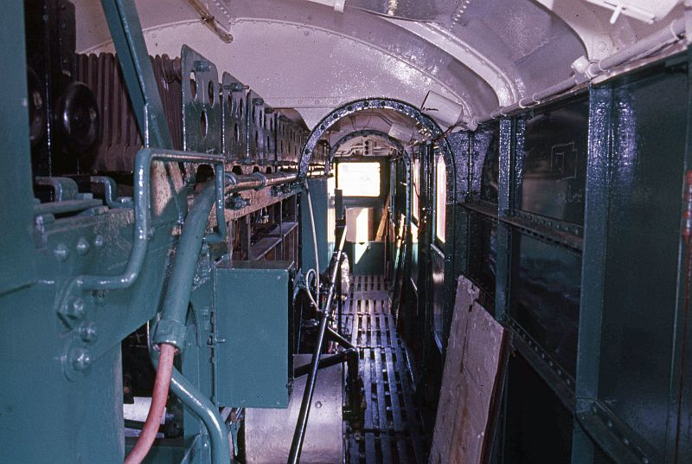
The next section describes the key features of the two cab variants, and will be followed by a detailed description of the controls operation.

An Overview of the Cabs
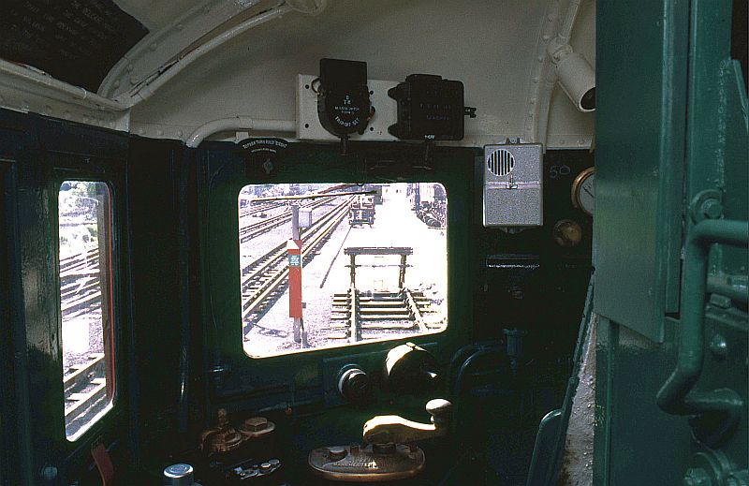
This is where you’ll be spending most of your time – the MSTS Met #12 Loco cab – viewed from behind the Motorman’s position. There are various switches and gauges, and three control stands. Following sections will illustrate the main cab features. Of particular interest are (L to R):
- The modern BR Type M6a train brake controller, operated by the operator’s left hand.
- The brass Westinghouse train brake controller.
- The wiper control, just below-left of the front window.
- The brass whistle button below the front window.
- The motoring control (Metropolitan-Vickers Type O-6-B Master Controller) operated by the operator’s right hand. The selector enabling Forward, Off and Reverse selections is on the left of the master controller and is operated by a removable lever.
- The duplex air pressure gauge, just visible on the front cab wall.

All therse controls and gauges will be shown in more detail in the next section.

CAB CONTROLS
The photo below provides more detail regarding the current cab controls. From left to right…
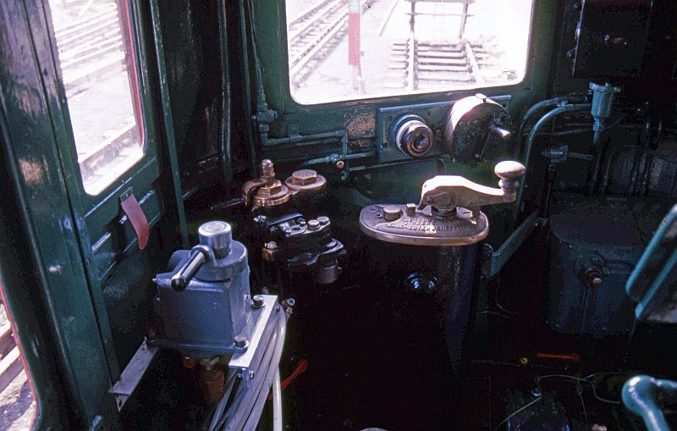
The current BR Type M6a EP train brake controller is on the left. It is shown in the Off/Release position (handle facing rearward). Moving the handle anti-clockwise applies increased train braking until about the 4 o’clock position. Emergency is at about 3 o’clock. Note that in the ‘original’ cab version of the MSTS loco, this brake controller is replaced with a Vacuum Brake controller.
The brass Westinghouse brake control stand is next, also shown in the Off/Release position. As MSTS can not model two brake systems at the same time, this controller is animated (using the loco brake keys) but is non-functional. In both versions of the cab the train and loco brakes are controlled together via the MSTS train brake keys; and the cab EP (or Vacuum) brake controller will animate accordingly.
The window wiper air control valve is located to the low-left of the front window. It is operated by the MSTS “V” (wiper) key and is animated. The brass loco whistle button is below the front window, to the right of the Westinghouse control stand. It is activated by the MSTS <space> key.
The Metropolitan-Vickers Type O-6-B Master Controller is shown in the OFF position with the deadman raised. Moving the handle clockwise will select successive motoring notches. With our other LUL stocks you will be used to using 4 notches (Off, Shunt, Series, and Parallel). This controller is slightly different as it has 5 total notches (4 plus Off). As W.A. Agnew describes it:
- Notch 1 – used for shunting and slow movements. Resistance connected in circuit with the motors in series combination. (This is equivalent to ‘Shunt’ on other controllers).
- Notch 2 – gives an automatic progression of seven steps which cut out all the resistance and leaves the motors free to run up to about half speed. (This is equivalent to ‘Series’ on other controllers).
- Notch 3 – connects the motors in parallel combination, each with an equal amount of resistance introduced in circuit. (This is new to you).
- Notch 4 – gives an automatic progression of five steps which cut out all resistance and leaves the motors free to run up to full speed. (This is equivalent to ‘Parallel’ on other controllers).
The ‘automatic progression of steps’ is achieved using a current-sensing circuit and a rotary pneumatic actuator operating cam controlled contactors. This is in a similar manner to today’s 73TS and D78 stocks.
The Selector has Forward, Off and Reverse positions. The selector handle is shown removed in the photo.
Between the front windows is the Duplex Air Gauge which has two needles. The red needle indicates main reservoir pressure, and the black needle shows brake line pressure. As you apply the train brakes the black needle will show a fall in pressure depending on the amount of braking. When the brakes are released the black needle will rise to its normal pressure and the red needle will fall slightly as the main reservoir re-charges the brake line. If the red needle falls sufficiently, it will trigger the compressors to re-charge the main reservoir. You will hear the compressors and see the red needle rise to its nominal pressure.
Not shown in the above photo, but present in the current-day loco, is a new panel containing a Digital Speedometer. This is reproduced in the MSTS modern-day cab.

Train Operation & Controls
Your first job as a Met #12 Loco Operator would be to open up the loco for service. This process is usually accomplished in the Depot and involves a set of prescribed procedures to make the loco ready for use -- these procedures ensuring that all equipment is operational and that the train can be motored. In the MSTS simulation, there are a few operations required before bringing the train into service that are intended to mimic these real-life procedures.

OPENING UP THE MSTS MET #12 LOCO FOR SERVICE
When you enter the Met #12 Loco train at the start of an MSTS activity or route exploration, the Selector (MSTS Reverser) will be in the OFF (Neutral) notch, the Train Brake controller will have a degree of braking applied, the Master Controller will be OFF, and the MSTS train lights switch will be OFF. You will also hear the air compressors bringing up the air pressure to its nominal value and see the duplex air gauge red needle rise to about 85psi. Before being able to motor the loco and begin your activity you will need to execute a few simple steps. You may also wish to review your Activity briefing to see what your simulated working entails.

TRAIN LIGHTS
The MSTS Met #12 Loco lights are controlled by the “H” and “Shift-H” keys. As all the train lights are currently OFF, you will need to press “H” once to turn on appropriate train lighting – i.e. turn on the front white lights (and the rear red lights if running light engine). Pressing “Shift-H” will turn the lighting back to OFF. The normal procedure, therefore, will be to turn on the correct front/rear train lights by pressing “H” once. You can use the exterior front and rear MSTS views (normally the “2” and “3” views) to confirm that the lights are operating. This simulates the real-life “walk around” the Operator would perform to verify operation of various items of train equipment. Note that if the loco is coupled to coaches (at either front or rear) only the required loco lights will illuminate.
As the train can be driven from either cab in MSTS, you will need to turn on the lights anytime you change cabs (via the ‘1’ key while at a stand). The white lights will be illuminated on the loco in the direction you (the operator) are facing, and/or the red lights to the rear of the loco when required. Uncoupling from the train will illuminate appropriate lights on your loco.

SELECTOR (MSTS REVERSER)
The Met #12 Loco selector has positions of FOR, OFF and REV, simulated in the MSTS Met #12 Loco with the FOR (forwards), OFF (neutral) and REV (reverse) positions. Note that in real life the REV position is very seldom used, as you can more easily view operations and control the loco by changing to the other-end cab. This cab changing is simulated in the MSTS loco using features provided by MSTS BIN. Details on how to change locos and cabs are given in a later section.
Note that MSTS BIN V1.7 or later is therefore required, else you will get errors when trying to run this loco. The loco was tested with MSTS BIN V1.8.052113.
As the Selector is currently in the OFF (neutral) position, you will need to press “W” to select FOR (forwards). Pressing “S” moves the selector back to OFF; a further press of “S” would select REV.
Note that when changing cabs, the direction you (the operator) are facing is always Forwards when motoring.

FINAL OPENING-UP CHECKS
Confirm that the correct loco lights are on. Traction current should be available. You can now test that the loco will motor by releasing the train brakes and briefly selecting the Shunt position on the Master Controller (MC), ensuring train forward movement occurs; and then returning the MC to OFF and re-applying the brakes. The following sections explain the Master Controller (MC) and Train Brake Controller operation in detail, including the keys used in MSTS to operate them.

MASTER CONTROLLER (MC)
The MC is a single-handle device (with a safety “dead-man” valve) that controls motoring (unlike the D78 CTBC which also controls braking). In general, you move the MC handle clockwise to increase acceleration and anticlockwise to reduce acceleration or to coast. The MSTS MC is a notched controller, having 4 distinct motoring positions (plus Off) that are used during various driving regimes.
The SHUNT, SERIES, SHUNT-PARALLEL and PARALLEL notches are used for motoring, and respectively provide increasing acceleration rates.
The OFF notch is used to coast, having reached a desired speed. The MSTS loco has good momentum and will coast realistically. Note that a typical consist (loco and 4 MK1 coaches) can approach 180 tonnes. This mass is more than that of a typical 6-car LUL passenger consist, and the inertia and momentum are higher.
Control of the MC in the MSTS Met #12 Loco is by using the “D” and ”A” keys, which move the MC clockwise and anticlockwise respectively. To perform the MSTS motoring check noted above, you would therefore release the brakes (see Train Brakes section, below) and move the MC from OFF to SHUNT by pressing “D” once. Once movement is confirmed, return to the OFF notch by pressing “A” once, and re-apply the brakes to stop the loco.

TRAIN BRAKES
The real Met #12 Loco originally used both Westinghouse and Vacuum brake systems to cater to differing coaching stocks. The current Met #12 uses Westinghouse and EP (air). You control the train brakes via the MSTS ‘ (quote) and ; (semicolon) keys. The brake level can be increased from its current setting, but can not be partially released. You can only fully release the brakes. This is due to a bug in MSTS.

DUPLEX AIR GAUGE
A few further words about the Duplex Air Gauge. As noted earlier, it has 2 needles – the red needle showing main reservoir pressure and the black needle showing train-line pressure. As the brake system has been modeled with accurate values, these needles will show correct pressures during various braking operations. The red needle will show a nominal 80-85psi, falling as the main reservoir pressure is used until the compressors cut-in at about 65-70psi. The needle will then show the re-charge back to nominal pressure during compressor operation (which will also be heard). The black needle will show a nominal 65psi, falling as train-line air is used (to 0psi for Emergency), and returning to nominal pressure when Off is selected on the brake controller.
As the duplex gauge will be in your peripheral vision in the MSTS cab display, we felt that it should operate correctly. However, an ex-LT Motorman has noted that when applying the brakes your attention should be out the front window -- and not looking at the duplex gauge ☺ Braking should be done by observation and feel and not reference to a gauge. After all, you don’t observe a car’s brake pedal to see how much brake you have applied. You simply apply and/or release until it “feels right”.

READY FOR SERVICE
By this point, you should be familiar with the important panels, switches, buttons, lights and movement controls; understand their purpose – and the MSTS keys that operate them.
The next sections present some anecdotal examples of how to drive the train as is done in real life. The MSTS Met #12 Loco uses realistic physics and controls, and you should find that the real-life examples presented can be achieved with some practice.

Driving the LT Met #12 Locomotive
These sections provide further information on how to drive the Met #12 Loco and use it in prototypical situations – couple/uncouple with coaches, shunting, driving the train, etc.

CHANGING CABS
This MSTS loco uses features in MSTS BIN and multiple cab definition files to enable driving from either cab in the loco. This is easily done and very useful when shunting, coupling, etc.
To change cabs, you must be at a stand with train brakes applied. Simply hit the ‘1’ key to change cabs. As the controls will be reset to their initial state, you will need to select FWD (“W”), turn on the loco lights (“H”), and release the brakes (semi-colon) and then motor.

COUPLING AND UN-COUPLING
This is the second LT/LUL stock we’ve produced that can actually couple and uncouple so it’s worth briefly describing how to do it successfully and safely. To couple to other units (e.g. a set of coaches), simply switch to the cab that faces them – so you can see what’s going on. Select FWD, release the brake and motor slowly towards the coaches at 2-3mph. CLUNK! Nice job.
To uncouple, hit F9 for the Train Operations display. Then double-click on the appropriate coupler. Set one or more coach brakes first!

COACHING STOCK HANDBRAKES
To set a coach handbrake, hit F9 for the Train Operations display. Then double-click on a coach. It will turn red indicating the brake is applied.

CONSISTS
The MSTS Met #12 Loco ships with 4 consists. You can select two variants of the loco on the loco selection screen in MSTS, and also select one of two variants for each loco (light engine, or with typical coaching stock for that variant). These are:
- The original Vacuum-braked loco
- The original logo plus 4 x GWR Concertina Dreadnaught coaches
- The modern EP braked loco
- The modern loco plus 4 x Mk1 coaches
The coaching stocks are NOT included in this kit, and must be downloaded separately. They may be obtained from UKTS as:
- File ID 15149 – Mk1 coaches (v6 Beta release), by Ian Morgan.
- File ID 18614 – GWR Concertina Dreadnaught coaches, by Frank Sandwell.
You may, of course, edit the consists to use whatever coaching stock you prefer. We used those listed above as we felt they best matched the coaching stock typically used by the loco variants in real life and on modern-day fan excursions.

TRAIN PHYSICS
Much time has been spent ensuring that the performance and behavior of the MSTS Met #12 Loco closely matches that of the real stock. When supplied with realistic data, the MSTS “physics engine” can produce very good results. This meant utilizing real values for such metrics as car weights and sizes, and determining the right aerodynamic drag and rail friction for the various units in the train set (thanks to Joe Realmuto’s FCALC2 program). The engine power, engine force (torque) and braking force were then be adjusted so as to achieve realistic acceleration, speed, and braking. Typical coasting behavior can also be achieved as a result of the train’s weight (momentum) and the drag/friction equations.
Don’t forget you are driving a train that weighs more than a typical LUL 6-car passenger set. The Met #12 Loco is powerful, but the laws of physics apply. The inertia and momentum of a heavier train are more pronounced. Moving off from rest will take longer, the effects of gradients will be different, and stopping will take more “thinking ahead” and care.
Some detailed aspects of the Met #12 Loco control systems can not be precisely modeled in MSTS. Similarly the precise behavior of the traction motors when using Series or Parallel motoring can not be exactly replicated. However, the effects of the real-life train systems have been simulated as closely as possible. Any exceptions to this relate to Kuju-imposed limitations in the Braking systems as discussed earlier.

EXAMPLE DRIVING PROCEDURES
The following are some example procedures that describe how to employ the controls to achieve the desired result. It is important to note that all speed limits and signals must be observed and obeyed, therefore you should always “look ahead” to anticipate any speed changes (acceleration or braking) that will be required.
You should consider the example procedures below as guidelines. The current line speed, gradients, home signaling and platform curvature (among other factors) will affect approach speed, braking points and brake rates to some degree. Using the example procedures shown below, coupled with knowledge of the line, will yield realistic train operation. One key point to remember is not to “drive the cab”. For example, before accelerating after crossing a turnout make sure the whole train is safely over – and not just your cab!

ACCELERATING IN GENERAL
When accelerating from rest it is most common in LUL passenger stocks to use Parallel motoring, so as to get up to line speed quickly. The Met #12 Loco is different, as it was designed to provide both high acceleration (for the train’s weight), to drive at moderate speeds (35-40mph) in congested areas, and also at high speeds (up to 65mph) on the Met Main. You should therefore start accelerating using Notch 2 (Series) and then progressively increase to Notches 3 and 4 as speed increases. In the MSTS loco, no harm will come from using Parallel (Notch 4) from rest – however it is not good driving and we suggest that part of the fun of this simulation is learning to do it the right way. Again, this is a heavy train, and most things happen slowly and carefully. Maximum speed of the MSTS loco has been limited to about 55mph.

COASTING IN GENERAL
Coasting is simply placing the MC in the Off notch and allowing the train to coast at the desired speed. Depending upon the gradient the train speed may decrease, increase, or remain about the same. On level track the speed will decay slowly due to aerodynamic drag and wheel friction, which are modeled. However given the train weight (momentum) the speed decay on level track will be quite gentle.

BRAKING IN GENERAL
A modest brake application is adequate to hold a train at rest on most gradients. Depending on the conditions and intentions, you may wish to apply one or more of the coach handbrakes. Do not forget to release them when required – it is very embarrassing to try and pull away and either pop the LC breakers or flat a few coach wheels. For a typical brake application (slowing or coming to a stand), you will add braking slowly and then apply more and more pressure as needed. This is because you cannot reduce the brake in the way that you can with the real system. To hold the brake pressure, move the lever to Hold. To release the brake go to Off.

SUMMARY
Operating the Met #12 Loco train efficiently will require practicing the above example procedures until you are comfortable with the train’s performance and know what to expect. Knowledge of the line is required so you can anticipate what actions may be required at various locations. Above all, have fun – driving the Met #12 Loco can be very rewarding one you have mastered the loco, its controls and the functions it can perform.
Welcome to the cab – we hope you enjoy the experience…

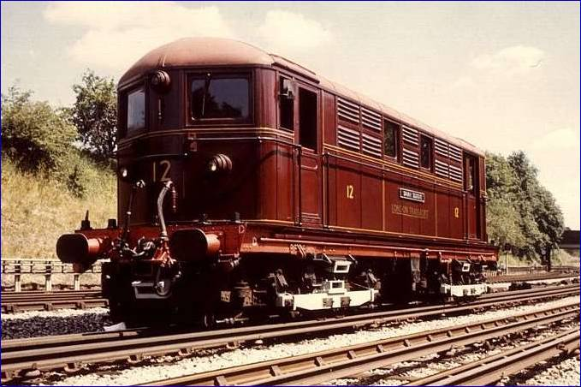

Notes, Acknowledgements & Credits
IMPORTANT NOTE: This train requires MSTS BIN for the cab/loco switching and the lighting systems to function correctly. It was tested with MSTS BIN V1.8.052113.
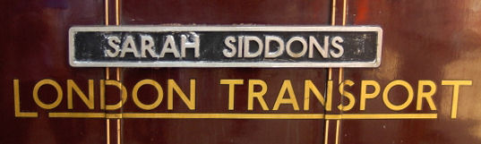
The Met #12 Loco models were created by Richard Scott. Richard’s high-quality freeware models, as well as his commercial work for 3DTS, are well-known to the MSTS community. These models are likely among his most realistic work.
The detailed 3D cab and animated controls were developed using 3DS Max software by Darren Carter. He has the knack of capturing the atmosphere of the old train stock cabs perfectly, and it was again a pleasure to collaborate with Darren and Richard on an LT/LUL Stock project.
I (Dr Jimi) was responsible for the controls/displays functionality, physics, sounds and lighting for the locos.
The train’s models, cab and realistic performance could not have been accomplished without the enthusiastic support and contributions of several LT/LUL professionals. We extend our sincere thanks to them for acting as technical consultants by sharing their knowledge and memories of “back in the day”.
This MSTS version of Metropolitan Loco #12 “Sarah Siddons” is respectfully dedicated to those who have preserved and maintained her in working order and who enable her to run today to the enjoyment of many.
We all hope you enjoy using this as much as we enjoyed creating it!
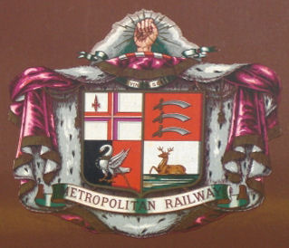
Photographs used herein are Copyright © 2008 by District Dave, Piccadilly Pilot and TubePrune, and are used with kind permission.
LT Met #12 Loco Virtual Motorman’s Guide. Document Copyright © 2008. Virtual District Line Team. All rights reserved.

